Solving Stiff Systems of Ordinary Differential Equations with Advanced Versions of the Richardson Extrapolation

Zahari Zlatev ¹⁾, Ivan Dimov ²⁾, István Faragó ³⁾, Krassimir Georgiev ²⁾ and Ágnes Havasi ³⁾

¹⁾ Department of Environmental Science, Aarhus University, Roskilde, Denmark
²⁾ Institute of Information and Communication Technologies, Bulgarian Academy of Sciences, Sofia, Bulgaria
³⁾ MTA-ELTE Numerical Analysis and Large Networks Research Group, Budapest, Hungary
and
Department of Applied Analysis and Computational Mathematics, Eötvös Loránd University, Budapest, Hungary

Abstract

Different versions of the Richardson Extrapolation can be used together with Implicit Runge-Kutta Methods (IRKMs) in the efforts to obtain more accurate results during the numerical solution of stiff systems of Ordinary Differential Equations (ODEs). Select an IRKM, the order of accuracy of which is $p≥1$. Assume that a $q$-Times Repeated Richardson Extrapolation, a $q$TRRE, $q∈\left\{0, 1, 2, ⋯,8\right\}$, where $q=0$ refers to the Classical Richardson Extrapolation (CRE) and $q=1$ refers to the Repeated Richardson Extrapolation (RRE), is used together with the selected IRKM. The order of accuracy of the resulting new numerical method, the combination IRKM+$qTRRE$, is $p+q+1$, which means that the accuracy can be increased substantially when an IRKM is applied together with some $qTRRE$, but there is a danger that the computational process will become unstable and, therefore, it is also important to preserve the stability during the solution. Two new concepts, practical absolute stability regions and practical A-stability, are introduced. An algorithm, by which it is possible to determine the practical absolute stability regions for any combination IRKM+$qTRRE$ when the stability function of the underlying IRKM is known is developed. The algorithm can also be used to investigate whether the studied IRKM+$qTRRE$ is practically A-stable. The application of the algorithm is straight-forward. It requires a lot of computations, but that is not a problem when modern computers are used. It is shown that the practical absolute stability regions of three well-known particular IRKMs combined with different $qTRRE are very large$. Moreover, the combinations of two of these particular IRKMs with the Classical Richardson Extrapolation lead to practically A-stable methods. Possibilities for generalizing further the results are briefly discussed.

Key words and phrases: Ordinary Differential Equations, Implicit Runge-Kutta Methods, Advanced Versions of the Richardson Extrapolation, Accuracy and stability, Practical Absolute Stability Regions, Practical A-stability.
AMS subject classification: 65L05, 65L06, 65L04.

1. Introduction

Consider the Initial Value Problem for a system of $s$ Ordinary Differential Equations (ODEs):

$$\left(1\right) \frac{dy}{dt}=f\left(t,y\right), t ∈ \left[a,b\right] , a<b, y ∈ R^{s} , f ∈ R^{s} , y\left(a\right)=η, s ≥1 .$$

It is assumed that the system of ODEs defined by (1) is stiff, which implies that implicit numerical methods must be used ([2], [3], [5], [7], [8], [9], [12], [14]). Approximations of the solution vector:

$\left(2\right) {y_{1}≈y(t}_{1})$, ${ y_{2}≈y(t}_{2})$, … , ${y_{n}≈y(t}_{n})$, … , ${y_{N}≈y(t}_{N})≈y\left(b\right)$

are calculated by applying the selected implicit numerical method on an equidistant grid:

$$\left(3\right) t_{0}=a, y_{0}=y\left(a\right)=η, t_{n}= t_{n-1}+h \left( n=1, 2, …, N \right), { t}_{N}=b, h=\frac{b-a}{N} .$$

The stepsize $h$ used in (3) is constant, but some results can be extended for non-equidistant grids.

Runge-Kutta methods are often used in the treatment of (1). These methods were introduced by Heun [11], Kutta [13] and Runge [16] and are described in many text-books on numerical solution of systems of ODEs ([2], [3], [7], [8], [9], [10], [14], [17] and [18]). The assumption that (1) is stiff implies that stable Implicit Runge-Kutta Methods (IRKMs) are to be selected and used. If it is desirable to increase the accuracy of the calculated results, then it is appropriate to apply different versions of the Richardson Extrapolation (defined originally in [15], see also [4], [6], [21], [22], [23], [24], [25], [26]). However, severe problems related to the preservation of the stability of the computational process based on the use of a combination of an IRKM with different versions of the Richardson Extrapolation may arise. It is proved in [23, p. 133], see also [5], that the combination of a numerical method with Richardson Extrapolation might be unstable even if the selected numerical method has very good stability properties (even if it is A-stable). This example shows clearly that it is both necessary and very important to develop a general algorithm, which can be easily used to study the stability properties of the combinations of any IRKM with a known stability function when it is applied together with different advanced versions of the Richardson Extrapolation. Such an algorithm is presented in Section 3 and stability regions obtained in the application of this algorithm in connection with three particular IRKMs listed in Section 4 and combined with several versions of the Richardson Extrapolation are discussed in Section 5. A family of numerical examples for testing the stability is constructed and used in Section 6. Several concluding remarks are given in Section 7.

Stability properties of the Classical Richardson Extrapolation and of some lower versions of the Repeated Richardson Extrapolation (One- or Two-Times Repeated Richardson Extrapolation) have been studied in several papers ([21] and [23]-[26]). The use of more advanced versions of the Richardson Extrapolation, up to Eight-Times Repeated Richardson Extrapolation, for non-stiff systems of Ordinary Differential Equations was studied in [22]. We shall extend the results presented in [22] for the important, from the practical point of view, case when the solved systems of Ordinary Differential Equations are stiff. This fact imposes very often great difficulties with the preservation of the stability during the computations and special methods, which both preserve the stability of the computational process and are sufficiently accurate, have to be developed and used.

2. Basic properties of the advanced versions of the Richardson Extrapolation

Several advanced versions of the Richardson Extrapolation were introduced and tested in [22] under two major assumptions: (a) the system of ODEs (1) is non-stiff and (b) Explicit Runge-Kutta Methods (ERKMs) can successfully be used during the solution process. Some of the main results reported in [22] and slightly modified for the purposes of the present paper are briefly discussed in this section. Then these results are applied to study the case where (1) is stiff, which implies, as mentioned above, the use of Implicit Runge-Kutta Methods (IRKMs). The stability properties of the combinations of IRKMs with advanced versions of the Richardson Extrapolation are discussed in the next section.

It is first necessary to describe the calculations that are to be carried out at a given step when an arbitrary IRKM is used together with a q-Times Repeated Richardson Extrapolation (a $qTRRE$).

Definition 1: Assume that (a) a stable IRKM is chosen, (b) an integer $q≥0$ is fixed and (c) a vector $y_{n-1}^{[q]}≈y(t_{n-1})$ is available. Use the selected IRKM with stepsizes $h,h/2, …,h/2^{q+1}$ to perform respectively $1,2, …,2^{q+1}$ steps and to calculate $q+2$ auxiliary vectors $z_{n}^{[0]}, z_{n}^{[1]}, …, z_{n}^{[q+1]}$. The first vector $z_{n}^{[0]}$ is calculated by performing one step with a stepsize $h$. The second vector $z_{n}^{[1]}$ is obtained by applying two steps with a stepsize $h/2$. It is necessary to continue in this way and the last auxiliary vector $z_{n}^{[q+1]}$ is obtained by performing $2^{q+1}$ steps with a stepsize $h/2^{q+1}$. The calculations used in the computation of any of the auxiliary vectors $z_{n}^{[i]}$, $i=0, 1, 2, …, q+1$ are started by $y_{n-1}^{[q]}$. Then the IRKM+$qTRRE$ vector $y_{n}^{[q]}≈y(t_{n})$ can be calculated by applying the following formula:

$$\left(4\right) y_{n}^{\left[q\right]}= \frac{P_{n}^{\left[q\right]}( z_{n}^{[q+1]}, z_{n}^{[q]}, …, z_{n}^{[0]})}{S^{\left[q\right]}} , n=1, 2, …, N and q=0, 1,… .$$
■

It is assumed in Definition 1 that the Classical Richardson Extrapolation (CRE) is used when $q=0$ while the Repeated Richardson Extrapolation (RRE) is used when $q=1$.

It is necessary to explain how the quantities $S^{\left[q\right]}$ and $P_{n}^{\left[q\right]}( z_{n}^{[q+1]}, z_{n}^{[q]}, …, z_{n}^{[0]})$ can be calculated.

Calculation of $S^{\left[q\right]}.$ It is proved in [22] that the values of $S^{\left[q\right]}$ for $q=0, 1,… , 8$ can be obtained by applying the following formula:
$$\left(5\right) S^{[q]}=\prod_{j=1}^{q+1}{\left(2^{p+j-1}-1\right)}, q=0, 1,… , 8 .$$
The calculation of $S^{[q]}$ by using (5) is a straight-forward but technically difficult task when $q$ is large. The computational work can be simplified by applying the recursive formula ([22]):

$$\left(6\right) S^{[q]}=\left(2^{p+q}-1\right)S^{[q-1]} , q=1, 2,… , 8 , assuming that S^{\left[0\right]}=2^{p}-1 .$$

The equalities (5) and (6) hold (a) for an arbitrary IRKM and (b) for any $q∈\{0, 1, …, 8\}$. It was furthermore conjectured in [22] that (5) and (6) are also true when $q>8$.
■

Calculation of $P_{n}^{\left[q\right]}( z_{n}^{[q+1]}, z_{n}^{[q]}, …, z_{n}^{[0]})$. Assume that $S^{[q]}$ is computed for some $q∈\{0, 1, …, 8\}$ by using (5) or (6). Then the terms in the expression $P_{n}^{\left[q\right]}( z_{n}^{[q+1]}, z_{n}^{[q]}, …, z_{n}^{[0]})$ can successively be calculated as follows. The first term in $P_{n}^{\left[q\right]}(z_{n}^{[q+1]}, z_{n}^{[q]}, …, z_{n}^{[0]})$ is obtained by multiplying the first term of $S^{[q]}$ by $z_{n}^{[q+1]}$. The second term in $P_{n}^{\left[q\right]}(z_{n}^{[q+1]}, z_{n}^{[q]}, …, z_{n}^{[0]})$ is obtained by multiplying the second term of $S^{[q]}$ by $z_{n}^{[q]}$. This process should be continued in the same manner and the last term in $P_{n}^{\left[q\right]}(z_{n}^{[q+1]}, z_{n}^{[q]}, …, z_{n}^{[0]})$ will obtained by multiplying the last term of $S^{[q]}$ by $z_{n}^{[0]}$.
■

The order of accuracy is increased when an IRKM is combined with a $qTRRE$, $0≤q≤8$.

Theorem 1: Let an IRKM, the order of accuracy of which is $p≥1$, be used together with some $qTRRE$ with $0≤q≤8$ to solve numerically (1). Then the order of accuracy of the new numerical method, the combination IRKM+$qTRRE$, will be at least $p+q+1$ if the right-hand-side $f\left(t,y\right)$ of (1) is at least $p+q+1$ times continuously differentiable.
■

Major relationships involving the stability functions of the IRKMs. Let$R\left(ν\right)$ be the stability function of an IRKM (the definition of the stability function of an IRKM can be found for example in [8], [9] or [14]). Assume that the selected IRKM is used to solve the following scalar and linear test-problem, proposed originally in [5]:

$$\left(7\right) \frac{dy}{dt}=λy, t ∈ \left.\left[0,∞\right. \right) , y∈C , λ=α+βi ∈ C^{-} , α≤0 , y\left(0\right)=η∈ C .$$

Then the relationships

$\left(8\right) y_{n}=R\left(ν\right) y_{n-1}= {\left[R\left(ν\right)\right]}^{2} y_{n-2}= ⋯ ={\left[R\left(ν\right)\right]}^{n} y_{0}, ν= hλ, n=1, 2, …$,

hold, [14], and, therefore, the computational process will be stable for $ν∈ C^{-}$ when $\left|R\left(ν\right)\right|≤1$.
■

Theorem 2: Consider an IRKM with a stability function $R\left(ν\right)$, $ν=hλ=h\left(α+βi\right)∈C^{-}$. Then the stability function $R^{[q]}\left(ν\right)$ of the combination of this IRKM with the $q$-Times Repeated Richardson Extrapolation, the $qTRRE$, $0≤q≤8$ , can be obtained by using the formula:

$${\left(9\right) R}^{[q]}\left(ν\right)=\frac{{\overline{P}}^{[q]}( R\left(ν\right))}{S^{\left[q\right]}} .$$
■

Calculation of ${\overline{P}}^{\left[q\right]}( R\left(ν)\right):$ Assume that $S^{\left[q\right]}$ is obtained by using either (5) or (6). The first term in ${\overline{P}}^{[q]}( R\left(ν\right) )$ can be found by multiplying the first term of $S^{\left[q\right]}$ by ${\left[R\left(ν)/(q+1\right)\right]}^{q+1}$. The second term in ${\overline{P}}^{[q]}( R\left(ν\right) )$ can be found by multiplying the second term of $S^{\left[q\right]}$ by ${\left[R\left(ν\right)/q\right]}^{q}$. The third term in ${\overline{P}}^{[q]}( R\left(ν\right) )$ can be found by multiplying the third term of $S^{\left[q\right]}$ by ${\left[R\left(ν)/(q-1\right)\right]}^{q-1}$. Continuing in this way, it is clear that the last term in ${\overline{P}}^{[q]}( R\left(ν\right) )$ can be found by multiplying the last term of $S^{\left[q\right]}$ by $R\left(ν\right)$.
■

Remark 1: All formulae for $S^{\left[q\right]},$ $P_{n}^{\left[q\right]}( z_{n}^{[q+1]}, z_{n}^{[q]}, …, z_{n}^{[0]})$ and ${\overline{P}}^{[q]}( R\left(ν\right) )$ when $q=0, 1, …, 8$, can be found in [22].
■

Conjecture 1: The assertions in Theorem 1 and Theorem 2 are true for any non-negative integer $q$.
■

It should be mentioned here that the results in this section are simple corollaries of results obtained in [22]. These results are needed and will be used in the following sections.

3. Stability properties of IRKMs applied together with $qTRRE$ ($q=0, 1, …, 8$)

The second theorem in Section 2, Theorem 2, is establishing a relationship between the stability function $R\left(ν\right)$ of an IRKM and the stability function $R^{[q]}\left(ν\right)$ of its combination with a $qTRRE$ when $q∈\left\{0, 1, …, 8\right\}$. Unfortunately, this relationship cannot be exploited to draw direct conclusions about the stability of different versions of the Richardson Extrapolation combined with IRKMs. Therefore, additional results related to the stability properties of the combinations of any IRKM with a $qTRRE$, are to be derived for $q∈\left\{0, 1, …, 8\right\}$. The fact that $R^{[q]}\left(ν\right)$with $q∈\left\{0, 1, …, 8\right\}$ can be calculated by using (9) when $R\left(ν\right)$ is known plays a central role in the construction of the important Algorithm 1 introduced in the end of this section. The application of this algorithm to study the stability of the three particular IRKMs from Section 4 combined with a $qTRRE$ with $q∈\left\{0, 1, …, 8\right\}$indicates that the computations will be stable in extremely large regions when these methods are applied in the solution of the test-equation $dy/dt=λy$ ($y∈C$ and $λ=α+ βi∈C^{-}$) from [5]. Similar results can be established for an arbitrary IRKM with a known stability function $R\left(ν\right)$ when this method is combined with any $qTRRE$ with $q∈\left\{0, 1, …, 8\right\}$.

Three parameters, $ω$, $ε$ and $τ$, are to be used in the construction of an algorithm for studying the stability properties of the combination of any IRKM with a $qTRRE$, $q=0, 1, …, 8$. The domain $Σ_{ω}$, in which it is desirable to study the stability, is determined by selecting an appropriate value of parameter $ω$ (Definition 2). A discretization of the specified domain is performed by applying the parameter $ε$ (Definition 3). The third parameter $τ$ is used in the stability checks (Definition 4).

Definition 2: If $ω$ is some positive real number, then $Σ_{ω}∈C^{-}$ is the square the vertices of which have coordinates $\left(0.0, 0.0i\right), \left(0.0, ωi\right), \left(-ω, ωi\right) and \left(-ω, 0.0i\right)$.
■

Definition 3: If $ε$ is some positive real number and $K$ is a positive integer such that $Kε=$ $ω$, then set $Σ_{ω}^{ε}$ contains all points with coordinates $\left(-kε, mεi\right)∈Σ_{ω}$ obtained by using $k=0,1,2, …, K$ and $m=0,1,2, …, K$. The${\left(K+1\right)}^{2}$ points in set $Σ_{ω}^{ε}$ can be considered as grid-points in the domain $Σ_{ω}$ which are obtained by using a discretization parameter $ε$.
■

Definition 4: Consider some $τ≥0$ and any IRKM with a known stability function $R\left(ν\right)$. Combine this IRKM with a $q$-times Repeated Richardson Extrapolation, a $qTRRE$, $q∈\{0, 1, …, 8\}$. Use (9) to calculate the values of the stability function $R^{\left[q\right]}\left(ν\right)$ at all points of $Σ_{ω}^{ε}$, i.e. to calculate the values of $R^{\left[q\right]}\left(ν\right)$ for $ν=\overline{α}+ \overline{β}i$, $\overline{α}=-kε$, $\overline{β}=mε$, $k=0,1,2, …, K$ and $m=0,1,2, …, K$. The points of the set $Σ_{ω}^{ε}$ for which the inequality $\left|R^{\left[q\right]}\left(ν\right)\right|≤1+ τ$ is satisfied will be called green points, while the name red points will be used for all points in $Σ_{ω}^{ε}$ for which $\left|R^{\left[q\right]}\left(ν\right)\right|>1+ τ$.
■

Assume that it is possible to apply exact arithmetic. Then the stability check $\left|R^{\left[q\right]}\left(ν\right)\right|≤1+ τ$ can be used with $τ=0$ and the calculations will be stable at the green points of $Σ_{ω}^{ε}$. More precisely, the following statement is true:

Statement 1: Assume that exact arithmetic is used with $τ=0$ and that $dy/dt=λy$ ($y∈C$ and $λ∈C^{-}$) is solved with some $h>0$ such that $hλ∈Σ_{ω}^{ε}$. Then the computations carried out by the combination IRKM+$qTRRE$ with $q∈\left\{0,1,2, …, 8\right\}$ will be stable according to the classical definition from [5] when $hλ$ belongs to the set of green points in $Σ_{ω}^{ε}$.
■

Values of $R^{\left[q\right]}\left(ν\right)$ are calculated by using exact arithmetic in Statement 1 and it is checked whether the requirement $\left|R^{\left[q\right]}\left(ν\right)\right|≤1$ is satisfied at the grid-points of $Σ_{ω}^{ε}$. It is desirable however that this inequality holds in the whole $Σ_{ω}$ when all grid-points of the set $Σ_{ω}^{ε}$ are green or at the part of $Σ_{ω}$ which contains only green points when there are both green and red points in $Σ_{ω}^{ε}$. Therefore, it is necessary to assume additionally that the discretization is fine, i.e. that $ε$ is sufficiently small. Then the computations related to the solution of $dy/dt=λy$ ($y∈C$ and $λ∈C^{-}$) from [5] should be expected to be stable in the whole $Σ_{ω}$ when all points of $Σ_{ω}^{ε}$ are green or in the part of the domain $Σ_{ω}$ which contains the green points of $Σ_{ω}^{ε}$ when there are both green and red points in this set. This observation allows us to formulate two statements. The first of these statements is useful in the attempts to generalize the classical concept of A-stability (the definition of A-stability can be found, for example, in [14]), while the second one allows us to generalize the concept of absolute stability region (see again [14]).

Statement 2: Assume that an IRKM+$qTRRE$ with $q∈\left\{0,1,2, …, 8\right\}$ is applied in the solution of the equation $dy/dt=λy$ ($y∈C$ and $λ∈C^{-}$) from [5]. If (A) exact arithmetic is used with $τ=0$, (B) $ε$ is sufficiently small and (C) all points of $Σ_{ω}^{ε}$ are green, then one should expect that the computations will be stable when $hλ∈Σ_{ω}$ or, in other words, one should expect that $Σ_{ω}$ is a part of the absolute stability region of the IRKM+$qTRRE$ in the sense of the definition from [5]. If the value of $ω$ is increased keeping $ε$ fixed and if all points of the increased set $Σ_{ω}^{ε}$ are still green, then a larger part of the absolute stability region will be obtained.
■

Statement 3: Assume that an IRKM+$qTRRE$ with $q∈\left\{0,1,2, …, 8\right\}$ is used in the solution of the equation $dy/dt=λy$ ($y∈C$ and $λ∈C^{-}$) from [5]. If (A) exact arithmetic is used with $τ=0$, (B) $ε$ is sufficiently small and (C) there are both green and red points in $Σ_{ω}^{ε}$, then one should expect the computations to be stable in the sub-domain of $Σ_{ω}$ which contains only the green points of $Σ_{ω}^{ε}$, i.e. the sub-domain of $Σ_{ω}$ which contains only the green points of $Σ_{ω}^{ε}$ is a part of the absolute stability region of the IRKM+$qTRRE$ in the sense of the definition from [5]. If $ω$ is increased keeping $ε$ fixed then a larger part of the absolute stability region might be obtained.
■

In the above statements it is assumed that exact arithmetic is used with $τ=0$. However, exact arithmetic cannot in general be applied when a computer is used in the calculations. The following example shows that the stability check $\left|R^{\left[q\right]}\left(ν\right)\right|≤1$ may sometimes cause difficulties when $R^{\left[q\right]}\left(ν\right)$ is calculated on computers. More precisely, the rounding errors are creating problems when the value of $R^{\left[q\right]}\left(ν\right)$ is very close to $1$. Assume that $ν=\overline{α}+\overline{β}i$ and that the Backward Euler Formula (see the next section) is used in a combination with the 7TRRE. Assume furthermore that $\overline{α}=0.000$ and that extended machine precision (involving computations with $32$ significant digits of the real numbers) is used during the calculations. Then $\left|R^{\left[7\right]}\left(\overline{α}+\overline{β}i \right)\right|-1≈1.7333*{10}^{-30}$ was found for $\overline{β}=0.004$. It is clear that this result may be affected by rounding errors and it is impossible, if the computer precision is fixed as above, to answer the question whether $\left|R^{\left[7\right]}\left(ν\right)\right|$ is greater than $1$ or whether it is less than $1$ at the point $\overline{α}+\overline{β}i=0.000+0.004i$. If it is necessary to find the answer of this question, then the application of more precise computer arithmetic (using for example $64$ significant digits of the real numbers) might give an answer. However, the answer is not very important in this case. The important issue is that $\left|R^{\left[7\right]}\left(0.000+0.004i\right)\right|$ is very close to $1$ and one should expect that the results of the computations will not be affected by computational instability even when the exact value of $\left|R^{\left[7\right]}\left(0.000+0.004i\right)\right|$, which we are not able to calculate with the selected extended precision computer arithmetic, is greater than $1$. This example shows clearly that it is worthwhile to introduce a stability check which is more suitable for computers. Such a check can be obtained by replacing the requirement $\left|R^{\left[q\right]}\left(ν\right)\right|≤1$, which causes difficulties when $\left|R^{\left[q\right]}\left(ν\right)\right|$ is very close to $1$, with a weaker requirement $\left|R^{\left[q\right]}\left(ν\right)\right|≤1+τ$ where $τ≥0$. However, the following remark shows that one must be careful.

Remark 2: If $τ>0$, then we may have $\left|R^{\left[q\right]}\left(ν\right)\right|>1$ at some of the green points of $Σ_{ω}^{ε}$ and the classical definition for absolute stability from [5] will not hold for such points. However, if $τ$ is sufficiently small and if a finite number of steps is to be carried out, then the effect of instability will not be observed during the actual computations at any of the green points of $Σ_{ω}^{ε}$.
■

The above remark shows that it is important to select properly the value of parameter $τ$. Many experiments indicate that $τ={10}^{-12}$ is giving good results when double precision computer arithmetic (working with sixteen significant digits of the real numbers) is used. This choice is a good compromise. It is not too close to the machine accuracy, which is $O\left({10}^{-16}\right)$. On the other hand, $\left|R^{\left[q\right]}\left(ν\right)\right|-1$ is small even if $1<\left|R^{\left[q\right]}\left(ν\right)\right|≤1+{10}^{-12}$. Other choices could also be made. If, for example, extended machine precision is to be used, then much smaller value of $τ$ might be selected.

Two concepts, practical absolute stability regions and practical A-stability, which are important when the stability properties of IRKMs combined with some $qTRRE$, $q∈\{0, 1, …, 8\}$, are to be investigated, can be introduced now.

Definition 5 (Practical A-stability): Assume that an IRKM+$qTRRE$, $q∈\left\{0,1,2, …, 8\right\}$, is used to solve the equation $dy/dt=λy$ ($y∈C$ and $λ∈C^{-}$) from [5]. If (A) $ω$ is very large, (B) $τ≥0$ and $ε>0$ are sufficiently small, (C) all points of $Σ_{ω}^{ε}$ are green and (D) the number of steps is finite, then one should expect that the results will be stable when $hλ=h\left(α+ βi\right)=\overline{α}+ \overline{β}i ∈Σ_{ω}$. The IRKM+$qTRRE$ will be called practically A-stable when these conditions are satisfied.
■

Definition 6 (Practical absolute stability regions): Let an IRKM+$qTRRE$, $q∈\left\{0,1,2, …, 8\right\}$, be used to solve the equation $dy/dt=λy$ ($y∈C$ and $λ∈C^{-}$) from [5]. If (A) $τ≥0$ and $ε>0$ are sufficiently small, (B) there are both green and red points in $Σ_{ω}^{ε}$ and (C) the number of steps is finite, then the sub-domain of $Σ_{ω}$ which contains only green points of $Σ_{ω}^{ε}$ is a part of the practical absolute stability region (if $ω$ is increased, but $τ$ and $ε$ are kept unchanged, then the part of the practical absolute stability region may also be increased). One should expect the computations to be stable when $hλ=h\left(α+ βi\right)=\overline{α}+ \overline{β}i$ is inside the practical absolute stability region.
■

Remark 3: The comparison of Definition 5 and Statement 2 indicates that the classical A-stability can be obtained as a boundary case of the practical A-stability when $ω→∞ ∧ ε→0 ∧ τ→0$. This means that the practically A-stable and the A-stable methods will have similar properties when $ω$ is large while both $ε$ and $τ$ are small. The comparison of Definition 6 and Statement 3 indicates that a part of the classical absolute stability region on the domain determined by the choice of parameter $ω$ can be obtained as a boundary case of the part of the practical absolute stability region when $ε→0 ∧ τ→0$. This means that if $ε$ and $τ$ are small, then the performance of the numerical methods when $hλ$ is belonging to the practical absolute stability region will be similar to the performance of the numerical methods when $hλ$ is belonging to the absolute stability region.
■

Remark 4: The regions of absolute stability are symmetric with regard to the real axis, [14], and it is sufficient to apply only non-negative values of $\overline{β}$ from $ν=hλ=h\left(α+ βi\right)=\overline{α}+ \overline{β}i$ when the absolute stability properties of the chosen numerical method are to be investigated. The same is also true if practical absolute stability regions and practical A-stability are considered, i.e. it is again sufficient to consider only non-negative values of $\overline{β}$ in the stability studies. This fact was exploited in the construction of the square $Σ_{ω}$ in Definition 2.
■

Remark 5: There is no need to require bounded approximations of the solution of $dy/dt=λy$ ($y∈C$) if $α>0$, i.e. if $λ∈C^{+}$, because the exact solution $y\left(t\right)= η e^{λt}$ of this equation is unbounded in this case. It is relevant to introduce the requirement $\left|R^{[q]}\left(ν\right)\right|≤1+τ$ (with some sufficiently small non-negative $τ$) and to study the practical absolute stability regions or the practical A-stability of the selected IRKM+$qTRRE$ with $q=0,1,2, …, 8$ only when $α≤0$.
■

Remark 6: The test-equation $dy/dt=λy$ ($y∈C$ and $λ∈C^{-}$) from [5] is rather special, but the importance of results derived by using this equation is emphasized in many books and papers; see, for example, [20, page 37]. It is of course desirable to obtain more general results. Many attempts to resolve this task and to proof stability results for more general cases, i.e. in connection with more general test-equations, have been carried out (see for example [2], [3], [8], [9], [12] and [14]). The above definitions and remarks can be modified and applied also for many of these test-equations.
■

Remark 7: A linear system $dy/dt=Ay$, ($y∈C^{s}$ and $A∈C^{sxs}$) can be considered instead of $dy/dt=λy$. If all eigenvalues $λ_{i}$ ($i=1, 2,⋯, s$) of matrix $A$ satisfy the condition $λ_{i}∈C^{-}$ and are distinct, then the system $dy/dt=Ay$ can be reduced to $s$ independent linear and scalar ODEs (see, for example, [14]) and the computational process will be stable if $\left|R^{[q]}\left(ν_{i}\right)\right|=\left|R^{[q]}\left(hλ_{i} \right)\right|≤1+τ$ holds with a sufficiently small $τ≥0$ for all eigenvalues of matrix $A$, i.e. the relation $hλ_{i}∈{\hat{Σ}}_{ω}$ (where ${\hat{Σ}}_{ω}$ contains only the green points of $Σ_{ω}^{ε}$) must be satisfied for all eigenvalues of matrix $A$.
■

Algorithm 1: Choose an arbitrary IRKM with a known stability function $R\left(ν\right)$ and select a large $ω$. Discretize the square $Σ_{ω}$ with vertices $\left(0.0, 0.0i\right), \left(0.0, ωi\right), \left(-ω, ωi\right) and \left(-ω, 0.0i\right)$ by using a small $ε>0$ to obtain a set of grid-points $Σ_{ω}^{ε}$. Consider some combination IRKM+$qTRRE$ with $q∈\{0, 1, …, 8\}$ and calculate the values of $R^{\left[q\right]}\left(ν\right)$ at all points of $Σ_{ω}^{ε}$. Use a small parameter $τ≥0$ to determine the green points in $Σ_{ω}^{ε}$, i.e. the points for which the inequality $\left|R^{\left[q\right]}\left(ν\right)\right|≤1+τ$ is satisfied. If $ε>0$ and $τ≥0$ are sufficiently small, then the sub-domain of $Σ_{ω}$which contains only green points of $Σ_{ω}^{ε}$ will be a part of the practical absolute stability region of the numerical method based on the selected combination IRKM+$qTRRE$ with $q∈\{0, 1, …, 8\}$. If furthermore all grid-points of set $Σ_{ω}^{ε}$ are green when the above conditions are satisfied, then the numerical method defined by the combination IRKM+$qTRRE$ with $q∈\{0, 1, …, 8\}$ is practically A-stable.
■

Remark 8: If exact arithmetic is used with $τ=0$ and with a sufficiently small $ε>0$, then a part of the absolute stability region, where the classical definition from [5] holds, will be determined when Algorithm 1 is used.
■

Remark 9: An example related to the choice of the parameters $ω$, $ε$ and $τ$ is given in Section 5.
■

Remark 10: All statements from the last two sections are valid for any method from the more general class of one-step methods for solving systems of ODEs if its stability function $R\left(ν\right)$ is known.
■

4. Selection of three particular Implicit Runge-Kutta Methods

Three representative IRKMs will be presented in this section. The practical absolute stability regions of the combinations of these methods with different versions of the Richardson Extrapolation will be studied, by using Algorithm 1, in the next section.

Backward Differentiation Formula: The Backward Differentiation Formula (well-known also as the Backward Euler Method) is a One-stage First-order IRKM. The abbreviation EULERB will be used. EULERB is an L-stable method for solving systems of ODEs ([2], [3], [9], [10], [12], [14], [19], [20]) defined by

$$\left(10\right) y_{n}=y_{n-1}+hf\left({t_{n}, y}_{n}\right), t_{n}∈\left\{a,b\right\} , y_{n}∈R^{s} , y_{n-1}∈R^{s} , f∈R^{s} , h>0 .$$

One system containing $s$ algebraic equations must be solved at every step and iterative procedures (normally some versions of the Newton Iterative Method) must be applied when (1) is non-linear.

Two-stage Third-order Diagonally Implicit Runge-Kutta Method (DIRK23 Method): The second particular method is an A-stable Two-stage Third-order Diagonally Implicit Runge-Kutta Method, a DIRK23 Method. It is based on the following formulae:

$$\left(11\right) y_{n}=\frac{1}{2}h\left(k_{1}^{n}+k_{2}^{n}\right) , y_{n}∈R^{s}, k_{1}^{n}∈R^{s} , k_{2}^{n}∈R^{s} , h>0,$$
$$\left(12\right) k_{1}^{n}=f\left({t_{n-1}+\frac{3+\sqrt{3}}{6}h, y}_{n-1}+\frac{3+\sqrt{3}}{6}hk_{1}^{n}\right) , t_{n-1}∈\left\{a,b\right\}, f∈R^{s} , { y}_{n-1}∈R^{s},$$
$$\left(13\right) k_{2}^{n}=f\left({t_{n-1}+\frac{3-\sqrt{3}}{6}h, y}_{n-1}-\frac{\sqrt{3}}{3}hk_{1}^{n}+\frac{3+\sqrt{3}}{6}hk_{2}^{n}\right) .$$

DIRK methods were introduced by R. Alexander [1] in 1977. The DIRK23 defined by (11) - (13) is taken from [14]. Only $k_{2}^{n}$ remains unknown in (13) when (12) is already solved and $k_{1}^{n}$ is found. This means that two systems of algebraic equations, each of them containing $s$ equations, have to be solved successively at every step. Iterative procedures (for example, the Newton Iterative Method) must be applied when (1) is a non-linear system of ODEs. The coefficients in front of $k_{1}^{n}$ and $k_{2}^{n}$ in the right-hand-sides of (12) and (13) are the same. Therefore, there is a good chance to solve the second system, (13), by using the factorization obtained during the solution of the system (12).

Three-stage Fifth-order Fully Implicit Runge-Kutta Method (FIRK35 Method): A well-known FIRK35 Method defined by equalities (14) - (17) was selected. This method is quoted in many text-books on numerical solution of ODEs, see, for example, [3], [8] and [9]. Let $h>0$. Consider some$t_{n-1}∈\left\{a,b\right\}$ and assume furthermore that ${ y}_{n}, y_{n-1}, k_{1}^{n}, k_{2}^{n}, k_{3}^{n}$ and$f$are vectors in $R^{s}$. Then the selected FIRK35 Method is based on the following formulae:

$$\left(14\right) y_{n}=\frac{16-\sqrt{6}}{36}hk_{1}^{n}+\frac{16+\sqrt{6}}{36}hk_{2}^{n}+\frac{1}{9}hk_{3}^{n} ,$$
$$\left(15\right) k_{1}^{n}=f\left({t_{n-1}+\frac{4-\sqrt{6}}{10}h, y}_{n-1}+\frac{88-7\sqrt{6}}{360}hk_{1}^{n}+\frac{296-169\sqrt{6}}{1800}hk_{2}^{n}+\frac{-2+3\sqrt{6}}{225}hk_{3}^{n}\right),$$
$$\left(16\right) k_{2}^{n}=f\left({t_{n-1}+\frac{4+\sqrt{6}}{10}h, y}_{n-1}+\frac{296+169\sqrt{6}}{1800}hk_{1}^{n}+\frac{ 88+7\sqrt{6}}{360}hk_{2}^{n}+\frac{-2-3\sqrt{6}}{225}hk_{3}^{n}\right),$$
$$\left(17\right) k_{3}^{n}=f\left({t_{n-1}+h, y}_{n-1}+\frac{16-\sqrt{6}}{36}hk_{1}^{n}+\frac{16+\sqrt{6}}{36}hk_{2}^{n}+\frac{1}{9}hk_{3}^{n}\right),$$
Systems of $3s$ algebraic equations are to be treated at every step when the above method is used. The Jacobian matrix of the system defined by (15) - (17) is a $\left(3s×3s\right)$ matrix. This causes a substantial increase of the computing work in comparison with the previous two methods where $\left(s×s\right)$ matrices are to be handled. Additional computational problems may arise when the Jacobian matrix of vector $f$ from (1) has some special property (which often happens in practice). The following example illustrates this fact. If the Jacobian matrix $∂f/∂y$ of vector $f$ from (1) is tridiagonal (which may occur when partial differential equations are semi-discretized, see for example [19] and [20]), then this feature can very efficiently be exploited when either EULERB or DIRK23 is used. The $\left(3s×3s\right)$ Jacobian matrix from (15) – (17) is not tri-diagonal and this is why FIRK35 is causing much more computational difficulties than EULERB and DIRK23 when the Jacobian matrix of $f$ is tridiagonal.

The FIRK35 has also some advantages: it is L-stable and very accurate, [3], [8], [9].

Basic properties of EULEB, DIRK23 and FIRK35: The basic properties of EULERB, DIRK23 and FIRK35 are described in Table 1.

Method | Stages | Accuracy | Stability | Stability function
EULERB | One | One | L-stable | $$R\left(ν\right)=\frac{1}{1-ν}$$
DIRK23 | Two | Three | A-stable | $$R\left(ν\right)=\frac{1-\left(\sqrt{3}/3\right)ν-\left[\left(1+\sqrt{3}\right)/6\right]ν^{2}}{1-\left[\left(3+\sqrt{3}\right)/3\right]ν+\left[\left(2+\sqrt{3}\right)/6\right]ν^{2}}$$
FIRK35 | Three | Five | L-stable | $$R\left(ν\right)=\frac{1+2ν/5+ν^{2}/20}{1-3ν/5+3ν^{2}/20-ν^{3}/60}$$
Table 1
Numbers of stages, orders of accuracy, types of stability and stability functions of the IRKMs introduced in this section

5. Stability of the three special IRKMs combined with $qTRRE$

The combinations of any of the three IRKMs from Section 4 with eight versions of the Richardson Extrapolation obtained with $q=0, 1, …, 7$ were systematically studied by using Algorithm 1 with $ω={10}^{5}$, $τ={10}^{-12}$ and $ε=0.1$. Several experiments with $q=8$ and/or $ε=0.001$ were also carried out. The results from all these investigations show that nearly all of the ${\left({10}^{6}+1\right)}^{2}$ grid-points of set $Σ_{ω}^{ε}$, obtained after the discretization of the square $Σ_{ω}$ with vertices $\left(0.0, 0.0i\right), \left(0.0, {10}^{5}i\right), \left(-{10}^{5}, {10}^{5}i\right) and \left(-{10}^{5}, 0.0i\right)$ by using $ε=0.1$, excepting quite a few points near to and on the imaginary axis, were green for all 27 methods (for the combinations of any of the three IRKMs with the nine versions of the Richardson Extrapolation). This means that one should expect the computations to be stable when the test-equation $dy/dt=λy$ from [5] is solved in a large part of the square $Σ_{ω}$ excepting some very small areas near to and on the imaginary axis.

The part of the practical absolute stability region for FIRK35+$7TRRE$ is given in Fig. 1. The instability intervals on the imaginary axis for the three IRKMs applied with eight versions of the $qTRRE$ ($q=0, 1, …, 7$) were determined by using two values of $ε$ ($ε=0.1$ and $ε=0.001$) and listed in Table 2. There are sometimes some small additional areas located very near to the imaginary axis, where the tested versions of the Richardson Extrapolation are unstable too. That is illustrated in Fig. 2 for the instability region of FIRK35+$7TRRE$ and in Table 3, where the intervals of instability near to the imaginary axis are given for $ε=0.001$ when EULERB is used together eight versions of the $qTRRE$ ($q=0, 1, …, 7$).

The region shown from Fig. 2 is the largest instability region of the tested methods, but it is negligibly small in comparison with the practical absolute stability region which is presented in Fig. 1. A small square with vertices $\left(0.0, 0.0i\right), \left(0.0, 900i\right), \left(-900, 900i\right) and \left(-900, 0.0i\right)$ is marked in red in Fig.1. The rectangle $\left(0.0, 0.0i\right), \left(0.0, 300i\right), \left(-0.3, 300i\right) and \left(-0.3, 0.0i\right)$ is a very small part (less than 0.01%) of the red square in Fig. 1. The instability region shown in Fig. 2 is located in this rectangle, but it does not fill the whole red rectangle. This fact is illustrating very well the statement that the part of the green square in Fig. 1, i.e. the part of the square with vertices $\left(0.0, 0.0i\right), \left(0.0, {10}^{5}i\right), \left(-{10}^{5}, {10}^{5}i\right) and \left(-{10}^{5}, 0.0i\right)$, in which the numerical method FIRK35+$7TRRE$ is not stable is negligibly small (it was not possible to show so small instability region in Fig. 1 and we had to mark in red a much larger area in the efforts to explain better the results). Similar conclusions can be easily derived for all other 26 combinations of the three particular IRKMs with $qTRRE$ ($q=0, 1, …, 8$).
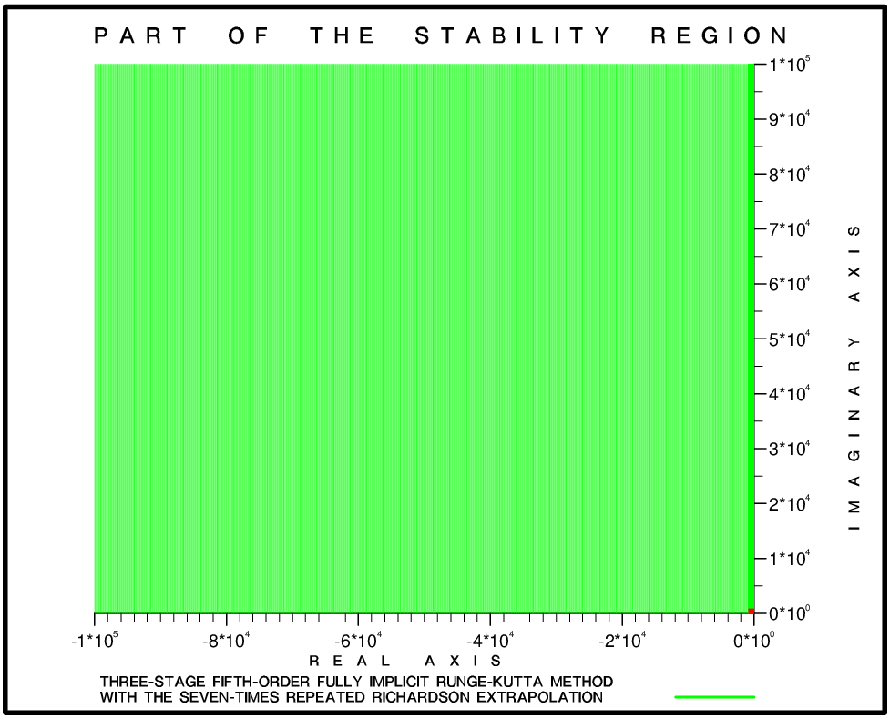

Figure 1
The green area is a part of the practical absolute stability region of the Three-stage Fifth-order FIRK Method when it is used together with the Seven-Times Repeated Richardson Extrapolation. This plot shows that one should expect that the computations will be stable nearly everywhere in a very large green square $Σ_{ω}$ whose side is ${ω=1.0*10}^{5}$ when the test-example $dy/dt=λy$ from [5] is solved. Some problems may arise only in a tiny area near to and on the imaginary axis (see also the results presented in Table 2, Table 3 and Fig. 2). A small area in Fig. 1 is marked in red. Instability may appear in a very small sub-region of the red area which is containing less than 0.01% of it.

Method | EULERB |  | DIRK23 |  | FIRK35
 | $$ε=0.1$$ | $$ε=0.001$$ | $$ε=0.1$$ | $$ε=0.001$$ | $$ε=0.1$$ | $$ε=0.001$$
CRE | No stability problems near to or on the imaginary axis |  |  |  | [0.2, 0.6] | [0.159, 0.605]
RRE | [0.1, 0.8] | [0.003, 0.861] | [0.1, 1.0] | [0.037, 1.002] | [0.3, 5.5] | [0.243, 5.501]
2TRRE | [0.1, 1.7] | [0.023, 1.709] | [0.2, 2.5] | [0.122, 2.518] | [0.4, 12.4] | [0.385, 2.455]
3TRRE | [0.7, 2.7] | [0.601, 2.748] | [1.0, 5.1] | [0.957, 5.181] | [8.1, 25.2] | [8.089, 25.269]
4TRRE | [1.3, 4.0] | [1.246, 4.080] | [2.6, 9.8] | [2.510, 9.877] | [1.0, 48.8] | [0.966, 48.859]
5TRRE | [0.3, 5.7] | [0.268, 5.774] | [5.5, 18.3] | [5.418, 18.373] | [1.6, 91.2] | [1.533, 91.213]
6TRRE | [0.6, 7.9] | [0.518, 7.901] | [1.7, 45.6] | [1.691, 45.687] | [8.1, 165.1] | [8.045, 165.169]
7TRRE | [1.0, 10.5] | [0.988, 10.527] | [3.1, 78.4] | [3.019, 78.402] | [3.9, 291.1] | [3.861, 291.138]
Table 2
Instability intervals on the imaginary axis when the three particular IRKMs are combined with the Richardson Extrapolation. The IRKM$+ qTRRE$ ($q=0, 1, …, 7$) is declared as unstable when $\left|R^{[q]}\left(ν\right)\right|=\left|R^{[q]}\left(hλ \right)\right|>1+{10}^{-12}$. Two values of $ε$ are used. The instability intervals are becoming slightly larger when $ε=0.001$ is selected. The results from the two tests indicate that the use of $ε=0.1$is sufficient. Both EULERB and DIRK23 are producing only green points, when the check $\left|R^{[q]}\left(ν\right)\right|=\left|R^{[q]}\left(hλ \right)\right|>1+τ$ with $τ={10}^{-12}$ is used with $q=0$, i.e. when the Classical Richardson Extrapolation (CRE) is used. It should also be noted that some of the methods are unstable not only on the imaginary axis but also in tiny areas near to the imaginary axis, see Fig. 2 and Table 3.

Version | $$\overline{α}$$ | Instability intervals $\left[β_{min},β_{max}\right]$ | max$\left(\left|R^{[q]}(ν)\right|\right)$
CRE | No stability problems near to or on the imaginary axis |  | 1.000000000000000
RRE | 0.000 | [0.001, 0.861] | 1.001409700579226
 | -0.001 | [0.521, 0.774]
2TRRE | 0.000 | [0.002, 1.709] | 1.002999016157321
 | -0.001 | [0.869, 1.649]
 | -0.002 | [1.071, 1.566]
3TRRE | 0.000 | [0.004, 2.748] | 1.002859386184047
 | -0.001 | [1.542, 2.659]
 | -0.002 | [1.848, 2.532]
4TRRE | 0.000 | [0.001, 4.080] | 1.002011478645706
 | -0.001 | [2.634, 3.904]
5TRRE | 0.000 | [0.001, 5.774] | 1.001134718380822
 | -0.001 | [4.529, 5.251]
6TRRE | 0.000 | [0.002, 7.901] | 1.000523089820448
7TRRE | 0.000 | [0.001,10.527] | 1.000196510143713
Table 3
Instability intervals near to and on the imaginary axis when EULERB is combined with eight versions of the Richardson Extrapolation. The results are obtained by using $ε=0.001$ and it is clearly seen that the regions of instability are considerably smaller than the region of instability of the FIRK35+$7TRRE$ shown in Fig. 2. No instability intervals are detected with the fine accuracy test used in the computations ($ε=0.001$) when the Classical Richardson Extrapolation is used, which indicates that the combination EULERB+CRE is practically A-stable.

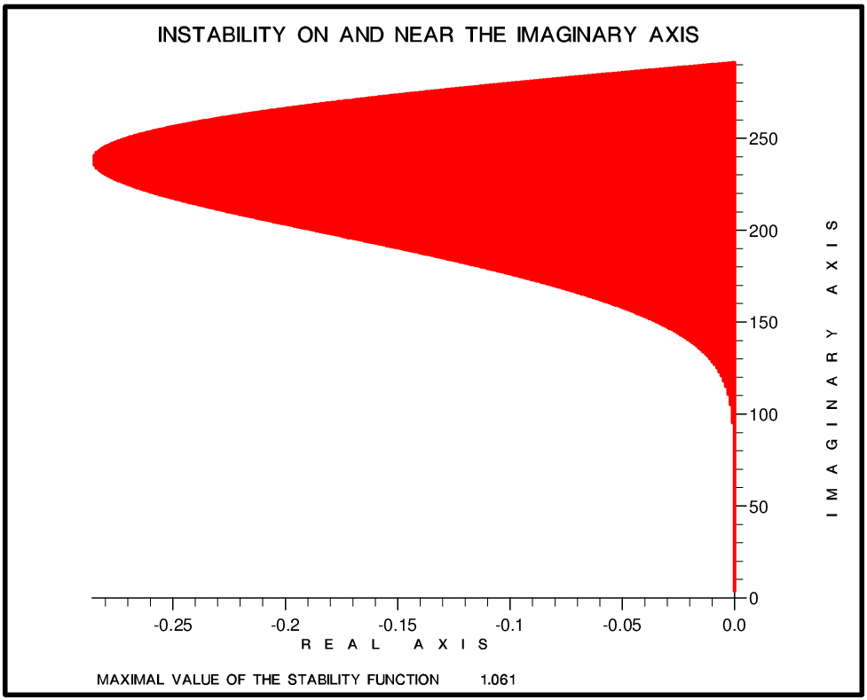
Figure 2
Instability region of FIRK35+$7TRRE$ obtained with $ε=0.001$. The maximal value of the stability function is 1.061. Many values of the stability function in the red area are in fact much smaller than 1.061 (but greater than $1+{10}^{-12}$ ).

6. Numerical results

The following three-parameters family was constructed and used systematically in the experiments:

$$\left(18\right) \frac{dy}{dt}=A y, t ∈\left[0,13.1072\right] , y={\left(y_{1}{, y}_{2},y_{3} \right)}^{T} , η=y\left(0\right)={\left(1,0,2 \right)}^{T} , A∈ R^{3x3}.$$

The elements of matrix $A$ from (18) depend on the parameters $ξ$, $γ$ and $δ$:

$$\left(19\right) a_{11}=-γ-ξ-2δ a_{12}=-γ-δ a_{13}= γ+ ξ+δ$$

$$\left(20\right) a_{21}= γ-2ξ+δ a_{22}= γ-ξ a_{23}=-γ+ ξ-δ$$

$$\left(21\right) a_{31}= -γ-3ξ-δ a_{32}=-γ-ξ-δ a_{33}= γ+ 2ξ$$

The three components of the exact solution of the problem defined by (18) – (21) are given by

$\left(22\right) y_{1}(t)=e^{-δt}sinξt+e^{γt}$, $y_{2}(t)=e^{-δt}cosξt+e^{γt}$, $y_{3}\left(t\right)=e^{-δt}\left(sinξt+cosξt\right)+e^{γt}.$

The eigenvalues of matrix $A$ the elements of which is defined in (19) - (21) are:

$\left(23\right) λ_{1}=γ≤0 , λ_{2}=-δ+ξi , λ_{3}=-δ-ξi , δ≥0$.

In order to ensure stable computations during the solution of this example, one should require that all three points $hλ_{1}$, $hλ_{2}$ and $hλ_{3}$ are inside the absolute stability region of the chosen numerical method for the selected value $h$ of the stepsize. The numerical results indicate that it is enough to require that all eigenvalues are inside the practical absolute stability region. The results remain very often stable even if the two points $hλ_{2}$ and $hλ_{3}$ are outside the practical absolute stability regions, but close to it. That is not a very big surprise because in this case $\left|R^{[q]}\left(hλ_{2} \right)\right|$ and $\left|R^{[q]}\left(hλ_{3} \right)\right|$ are greater than $1+{10}^{-12}$ but still very close to this number.

It can easily be seen, by studying the formulae representing the exact solution and the eigenvalues of matrix $A$, that the three-parameters family defined by (18) – (23) has the following properties:

(a) Increasing the absolute value of $γ$ and keeping the values of $ξ$ and $δ$ fixed, leads to an increase of the stability requirements on the negative real axis. That is especially pronounced when $\left|ξ\right|$ and $δ$ are kept small. If this is so and $\left|γ\right|$ is large, then it will be enough to require that $hλ_{1}=hγ$ is inside the absolute stability interval on the negative real axis.

(b) Increasing the value of $\left|ξ\right|$ leads to an increase of the oscillations and, thus, to an increase of the accuracy requirements. This is clearly seen by comparing the four plots given in Fig. 3. These plots show that the increase of the value of parameter $\left|ξ\right|$ is causing a very significant increase of the number of oscillations and, thus, of the accuracy requirements during the numerical solution. It is becoming more and more difficult to satisfy the accuracy requirements when parameter $\left|ξ\right|$ is increased. However, very large values of $\left|ξ\right|$ will also cause stability problems related to the height of the practical absolute stability region (the influence of the complex eigenvalues is becoming more and more significant when $\left|ξ\right|$ is becoming very large).

(c) By varying the value of $δ$ one can move the complex eigenvalues either close to the imaginary axis or long away from it. If it is interesting to study the stability properties of the tested numerical method at the critical points located either near to or even on the imaginary axis, then small values of $δ$ or even $δ=0$ should be selected.

This short analysis shows clearly that it is possible to change systematically the locations of the eigenvalues of matrix $A$ in the negative part of the complex plane and to steer in this way both the accuracy requirements and the stability requirements by selecting appropriate values of the three parameters. We are interested in testing the stability of the methods in a small area near to and on the imaginary axis, where difficulties may appear (see the results in the previous section). Therefore, we carried out experiments both with small positive values of $δ$ and with $δ=0$.

In the tests the values of $γ$ and $δ$ are fixed ($γ=-75000$ and $δ=0.03$) and four values $ξ$ ($ξ=2$, $ξ=8$, $ξ=32$ and $ξ=128$) are used. The plots of the first component of the exact solution when the parameters are selected in this way are shown in Fig. 3. It is seen that the number of oscillations is increased very quickly when parameter $ξ$ is becoming larger. The behaviour of the other two components of the solution vector is very similar.

The computations are organized in the following way. The interval $\left[0, 13.1072\right]$ was divided into $128$ equal sub-intervals. The accuracy of the computed results obtained by the three numerical methods from Section 4, when these are applied both directly and in combination with any of the eight versions of the Richardson Extrapolation, was estimated at the end of each sub-interval. Let ${\overline{t}}_{j} , j∈\left\{1, 2, …, 128\right\} ,$ be the end-point of any of the $128$ sub-intervals. The notation ${\overline{y}}_{ij}≈y_{i}\left({\overline{t}}_{j}\right)$, where $i∈\left\{1, 2, 3\right\}$ will be used and ${\overline{y}}_{ij}$ is calculated by applying one of the three selected IRKMs either directly or in combination with some version of the Richardson Extrapolation. Then the accuracy achieved by the selected numerical method at the point $t={\overline{ t}}_{j}$ can be evaluated by using the following formula:
$$\left(24\right) {ERROR}_{j}= \frac{\sqrt{\sum_{i=1}^{3}{{\left(y_{i}\left({\overline{t}}_{j}\right)-{\overline{y}}_{ij}\right)}^{2}} } }{max\left[ \sqrt{\sum_{i=1}^{3}{{\left(y_{i}\left({\overline{t}}_{j}\right)\right)}^{2}}} , 1.0\right]} .$$
The global error is computed by using the values of ${ERROR}_{j}$ from (24) in the following manner:

$$\left(25\right) ERROR= \max_{j=1, 2, … , 128}{ \left({ERROR}_{j}\right)} .$$

The selected three particular IRKMs and the combinations IRKM+ $qTRRE$ ($q=0, 1, …, 7$) were run with four values of $ξ$ ( $ξ=2, ξ=8, ξ=32 and ξ=128$) and with 12 different stepsizes We are starting the computations with $h=0.02048$, halving the stepsize after each successful run, and finishing with $h={10}^{-5}$ in the twelfth run. This means that results from 1296 runs will be compared and discussed.

It must be emphasized here that all results are calculated by selecting quadruple-precision (i.e. by applying $REAL*16$ declarations for the real numbers, which means that the computations are carried out by using about $32$ significant digits of the real numbers).

Logarithms of the errors are used in the plots presented in Fig. 4, Fig. 5 and Fig. 6 when EULERB, DIRK23 and FIRK35 are used, both directly and in combination with eight versions of the Richardson Extrapolation, in the solution of the test-problem defined by (18)-(21).

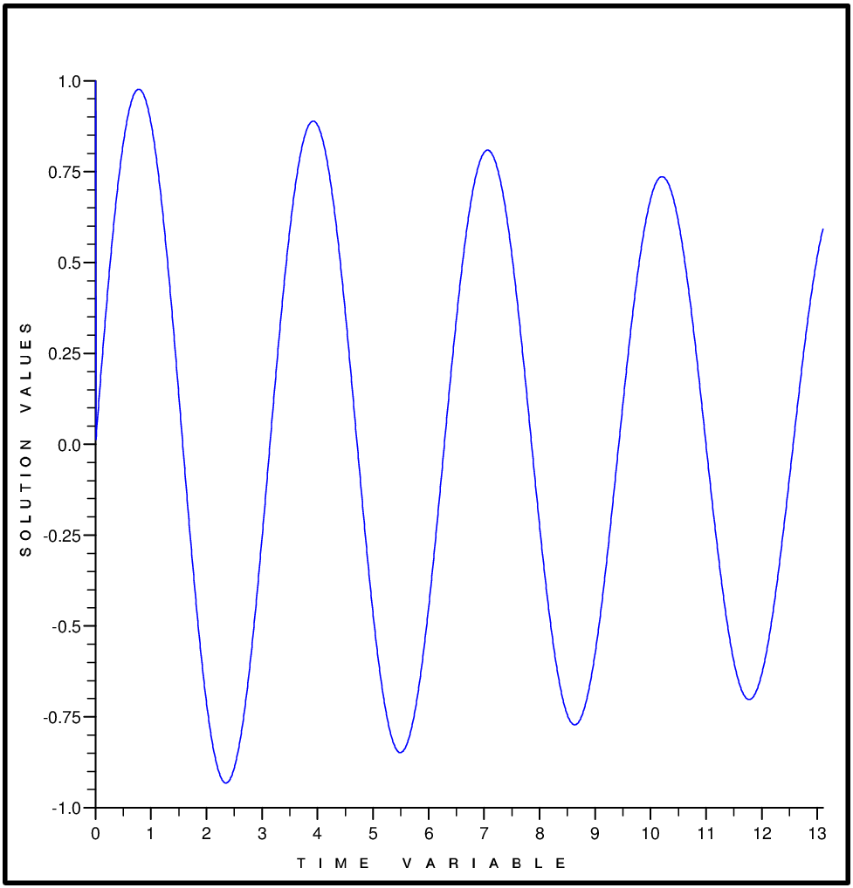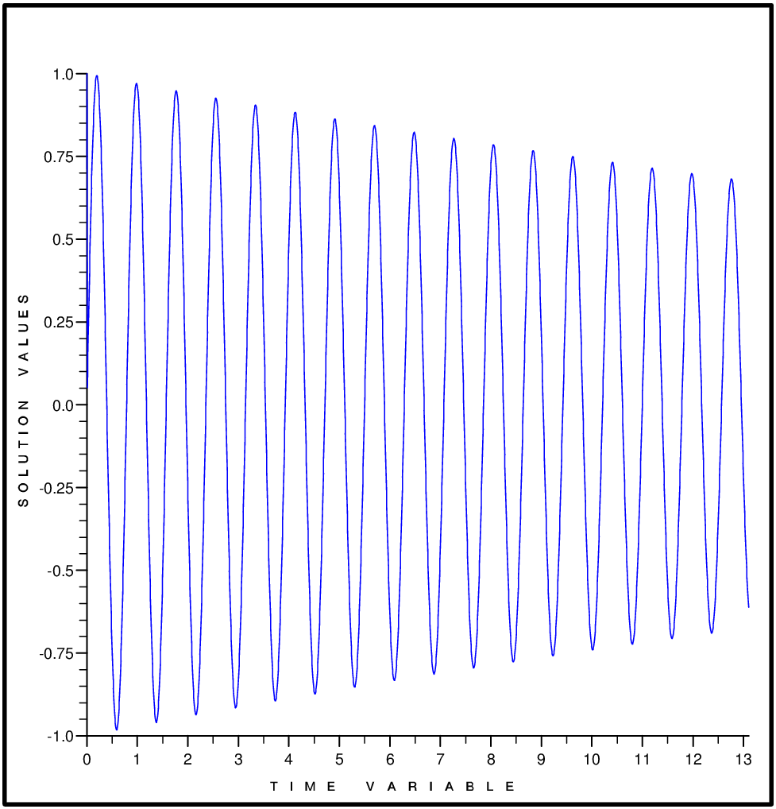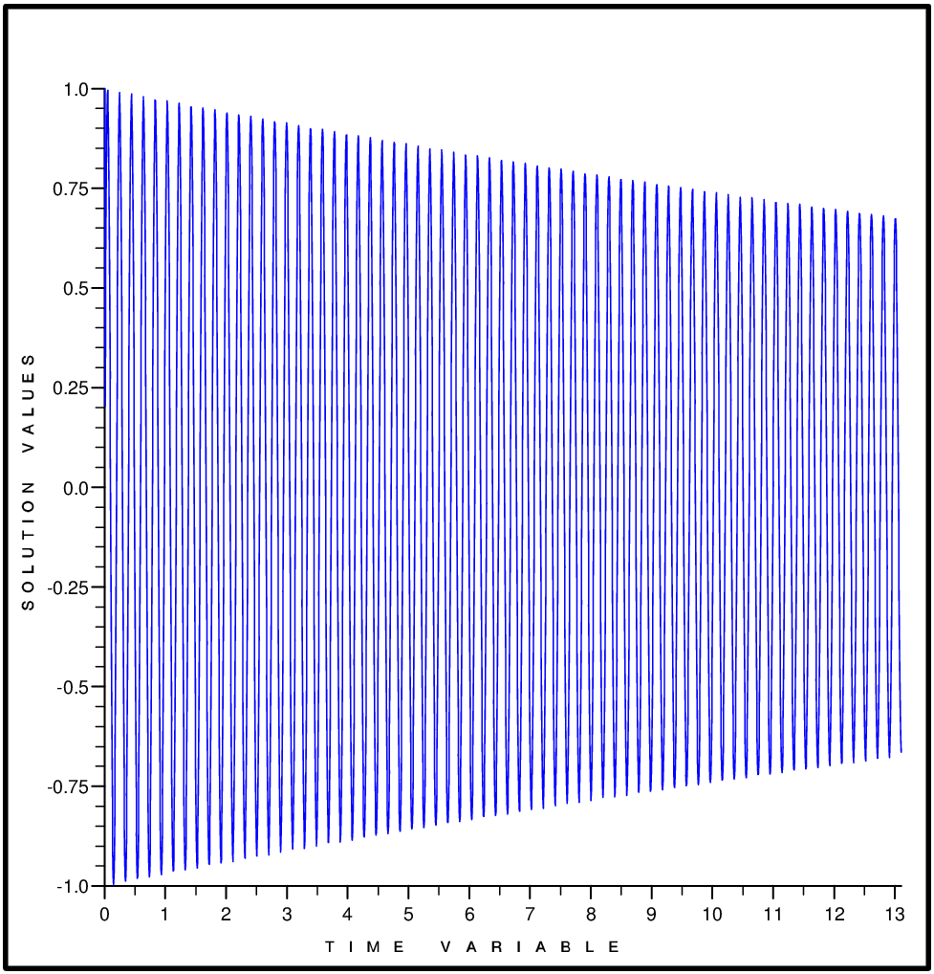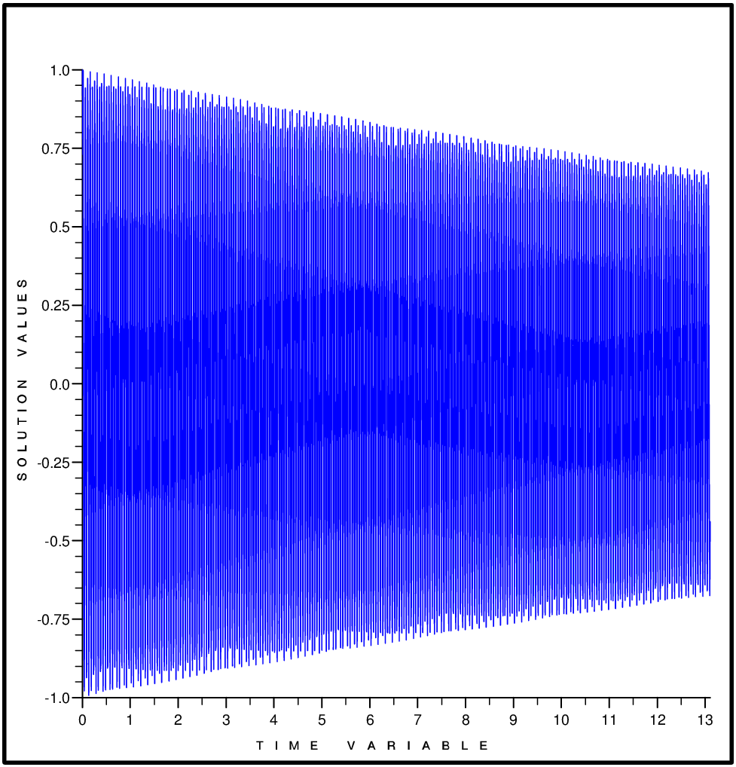
Figure 3
The first component of the solution of the linear system of ODEs represented by (18) – (21) obtained when the values of the first parameter are $ξ=2$ (the upper left-hand-side plot), $ξ=8$ (the upper right-hand-side plot), $ξ=32$ (the lower left-hand-side plot) and $ξ=128$ (the lower right-hand-side plot). The other two parameters are $γ=-75000$ and $δ=$0.03 in all four plots. It is clearly seen that the number of oscillations is increased very substantially and, therefore, the accuracy requirements are increased when parameter $ξ$ is becoming larger.

A requirement to calculate approximations with at least two correct significant digits is satisfied when the curves drawn in these three figures are under the dotted line.

Comments about the results obtained by EULERB: The requirement for achieving at least two correct significant digits is not satisfied when this method is used directly with $ξ=32 or ξ=128$. That is true even if the smallest stepsize is used and more than one million steps are carried out. On the other hand, if the advanced versions of the Richardson Extrapolation are used, then the calculated results are often becoming very accurate and the rounding errors are gradually starting to be dominating in spite of the fact that quadruple precision is used.

Comments about the results obtained by using DIRK23: The results obtained by using DIRK23 are in general more accurate than the corresponding results obtained by applying EULERB, but if this method is used directly with large stepsizes then the requirement for achieving at least two correct significant digits is again not always satisfied. If advanced versions of the Richardson Extrapolation are used, then the calculated results are often becoming very accurate and the rounding errors are quickly starting to be dominating.

Comments about the results obtained by using FIRK35: The results obtained by using this method are more accurate than the corresponding results obtained by applying the other two methods. If FIRK35 is used directly and if $ξ=128$, then the required accuracy (at least two correctly calculated significant digits) is not achieved if the stepsize is large. If the advanced versions of the Richardson Extrapolation are used, then again the calculated results are very often becoming very accurate and the rounding errors are very quickly starting to be dominating.

The results in Fig. 4, Fig. 5 and Fig.6 show clearly that the accuracy of the results is quickly increased both when the stepsize is decreased and when more accurate versions of the Richardson Extrapolation are used. It is also important to know whether the theoretical convergence rates (according to Theorem 1) can be achieved. It is seen from Table 4 that the methods are performing very well and the practically achieved convergence rates are very close to expected rates.

7. Plans for future research

Future research can be carried out in different directions. Some examples are listed below.

Further extension of the stability results: Two new concepts, practical A-stability and practical absolute stability regions, were introduced in Section 3. Stability properties of the combinations of the three particular IRKMs from Section 4 combined with different versions of the Richardson Extrapolation were studied in Section 5. It is worthwhile to apply Algorithm 1 from Section 3 to some other IRKMs and even to some one-step methods when these are combined with any $qTRRE$ with $q∈\left\{0,1,2, …, 8\right\}$. It is desirable to find IRKMs which produce practically A-stable methods for all IRKM+$qTRRE$ with $q∈\left\{0,1,2, …, 8\right\}$. It will also be useful to obtain also some extensions to the concepts of strong A-stability and L-stability.

More numerical tests: It will be useful to carry on experiments by using problems arising in large-scale scientific and engineering models. A non-linear atmospheric chemistry scheme from an air pollution model, which is very stiff, ill-conditioned and badly scaled ([19], [20]) will also be tested.

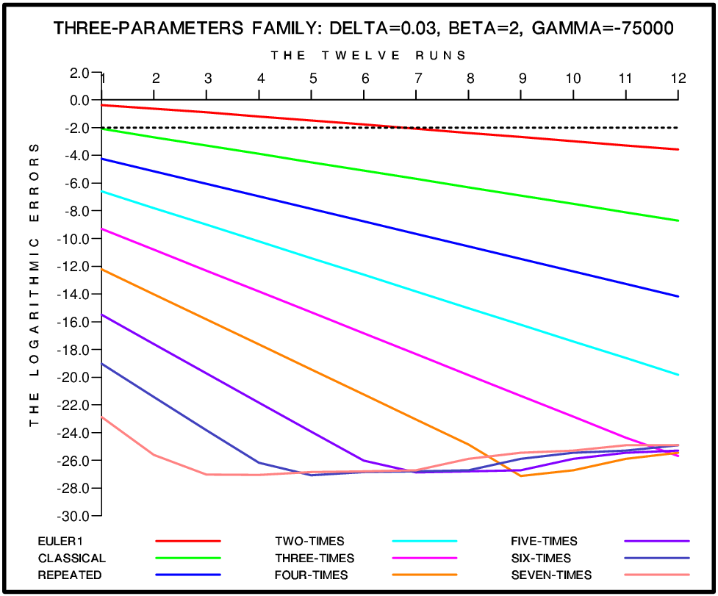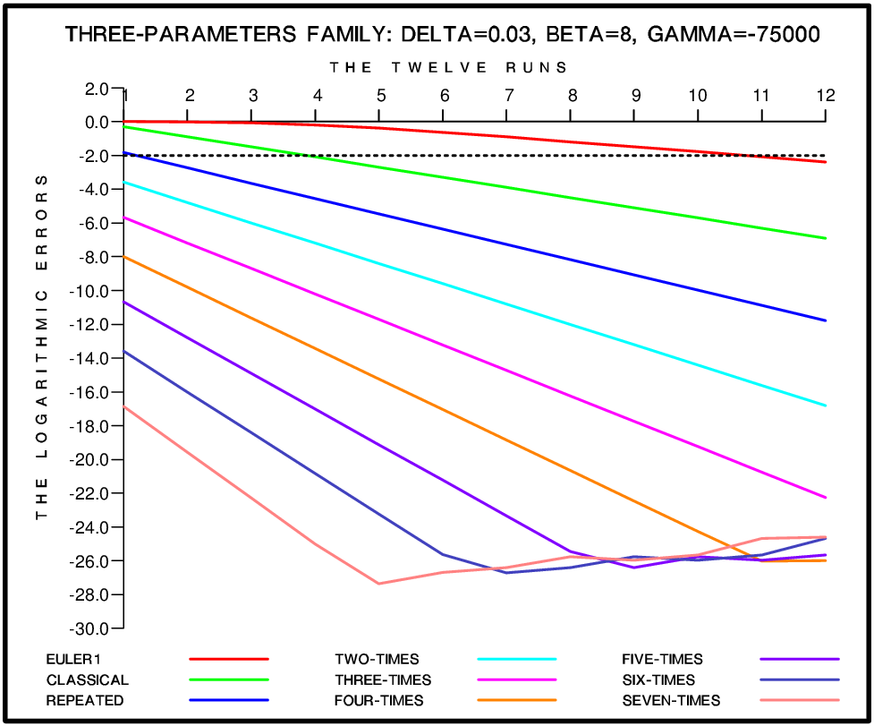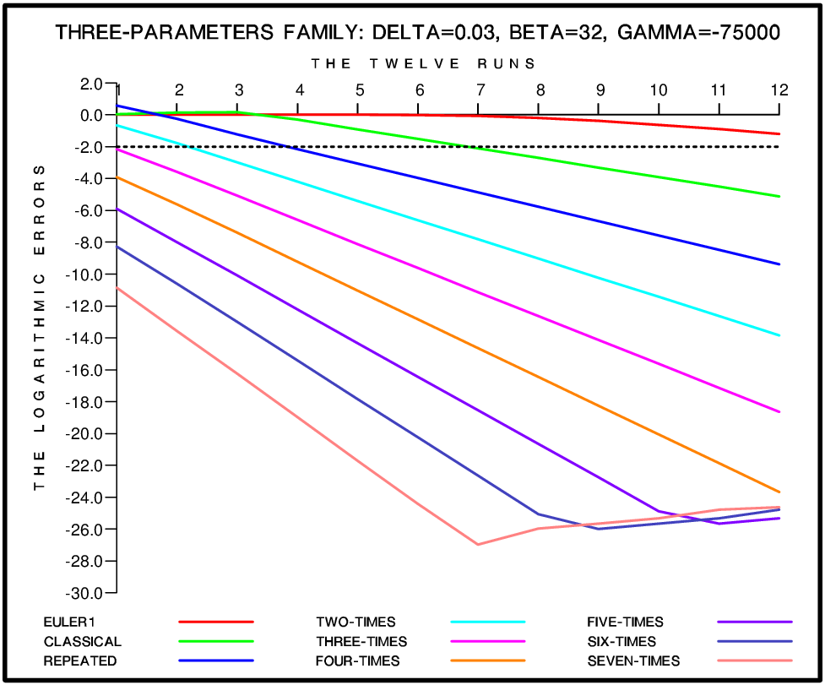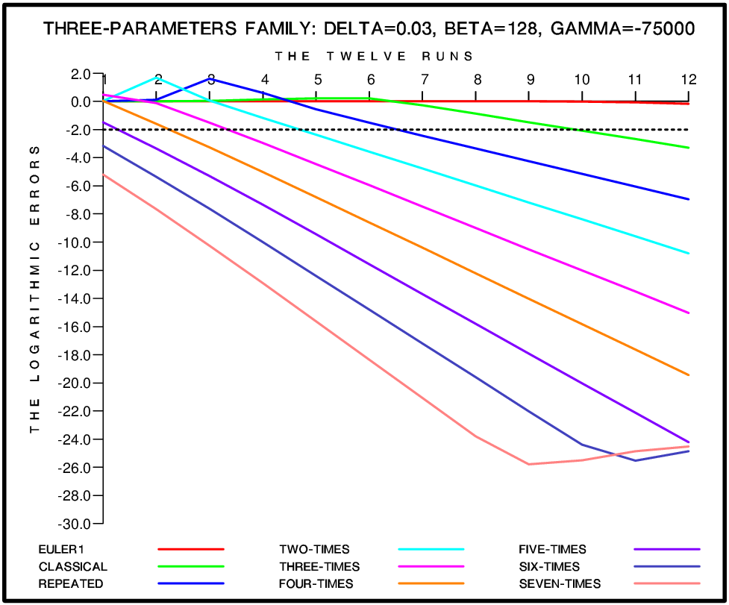
Figure 4
Logarithmic values of the errors in the solution vector when EULERB is used directly and with eight versions of the Richardson Extrapolation. Twelve different stepsizes are used and the errors are evaluated by applying (24) and (25). The names DELTA, BETA and GAMMA are used in the plots instead of $δ$, $ξ$ and $γ$.

Automatic variation of the stepsize and the versions of the Richardson Extrapolation: It will be useful to develop a reliable and efficient software, which will allow the users to solve their problems by automatically changing both the stepsize and the used versions of the Richardson Extrapolation according to prescribed requirements. The checks for changing the stepsize and/or the used version of the Richardson Extrapolation are normally related to the required accuracy, but there is always an additional requirement related to the preservation of the stability of the computations. Therefore, it was very important to show that one should expect the computations to remain stable in very large practical absolute stability regions, when some well-known IRKMs are used together with different versions of the Richardson Extrapolation.

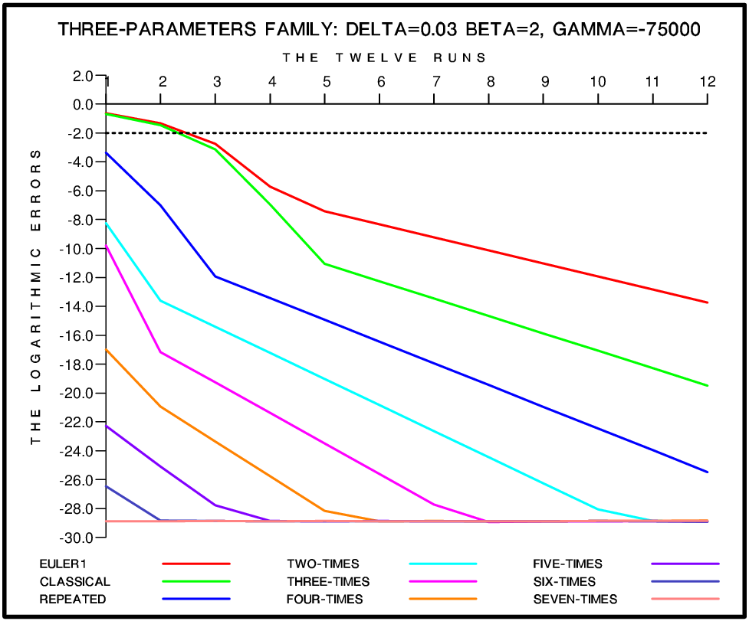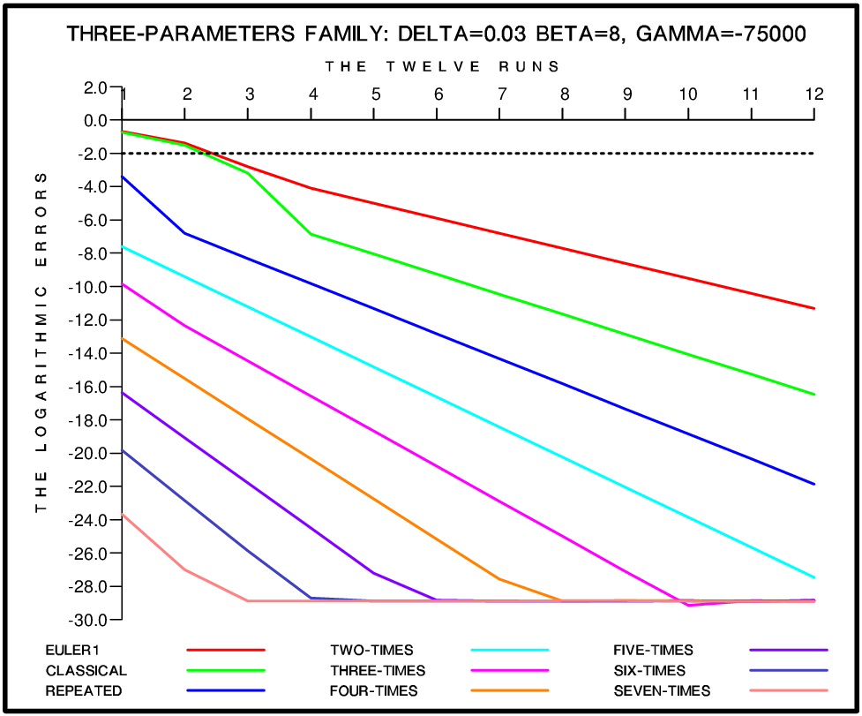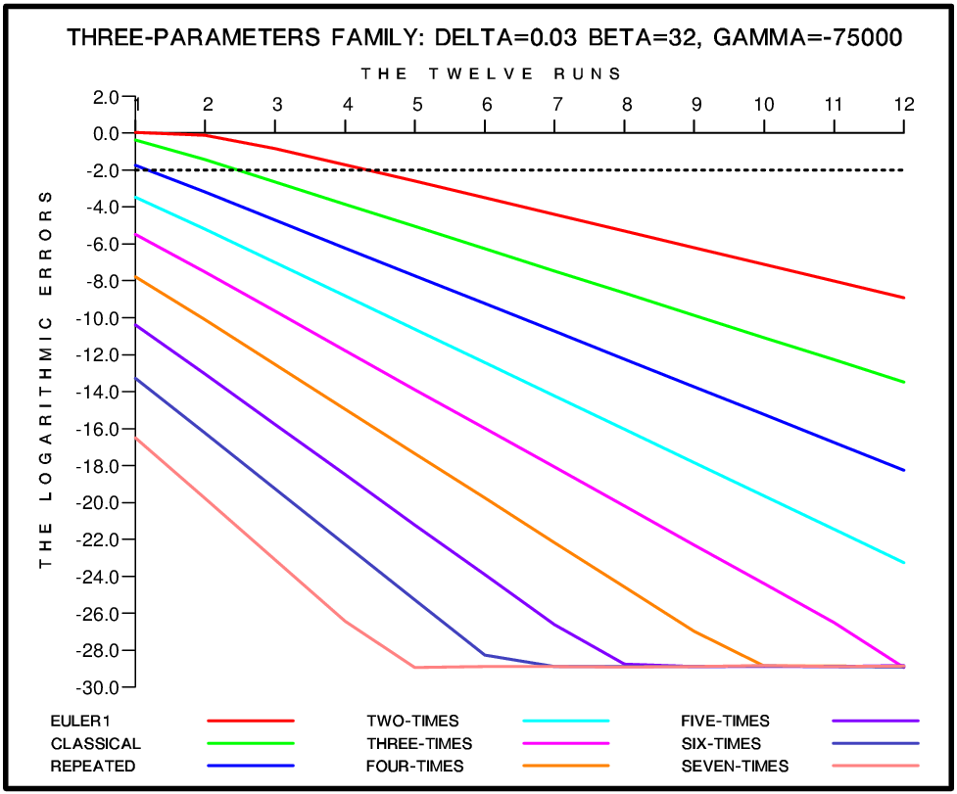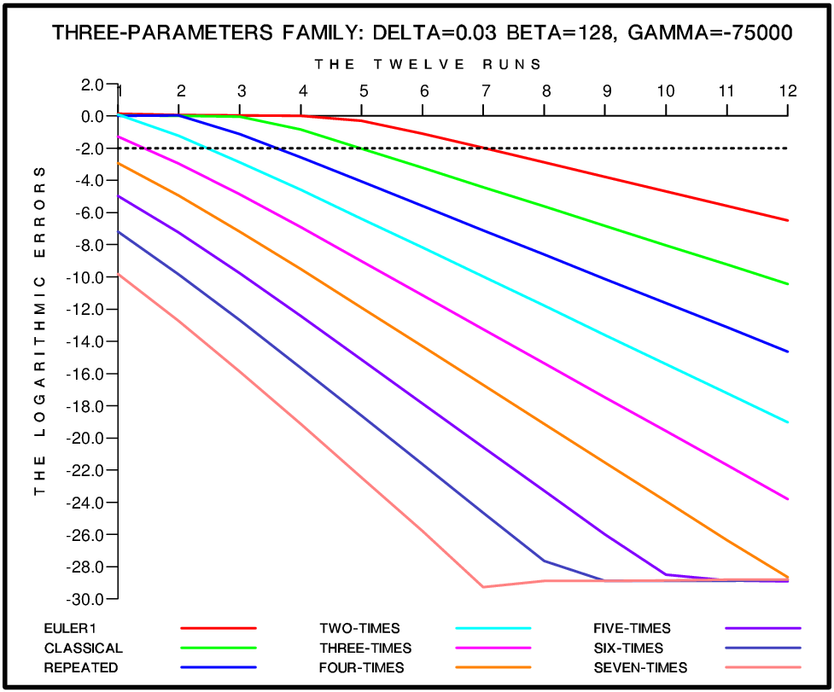
Figure 5
Logarithmic values of the errors in the solution vector when DIRK23 is used directly and with eight versions of the Richardson Extrapolation. Twelve different stepsizes are used and the errors are evaluated by applying (24) and (25). The names DELTA, BETA and GAMMA are used in the plots instead of $δ$, $ξ$ and $γ$.

References

[1] R. Alexander: “Diagonally implicit Runge-Kutta methods for stiff ODE’s”, SIAM Journal of Numerical Analysis, Vol. 14 (1977), pp. 1006-1021 (http://www.jstor.org/stable/2156678).

[2] K. Burrage: “Parallel and Sequential Methods for Ordinary Differential Equations”, Oxford University Press, Oxford-New York, 1995 (https://www.biblio.com/9780198534327).

[3] J. C. Butcher: “Numerical Methods for Ordinary Differential Equations”, Second edition, Wiley, New York, 2003 (https://doi.org/10.1002/9780470753767).

[4] E. Christiansen. and H. C. Petersen: “Estimation of convergence orders in repeated Richardson extrapolation”, BIT, Vol. 29 (1989), pp. 48-59 (https://doi.org/10.1007/BF01932705).

[5] G. Dahlquist: “A special stability problem for linear multistep methods”, BIT, Vol. 3 (1963), pp. 27-43 (https://doi.org/10.1007/BF01963532).

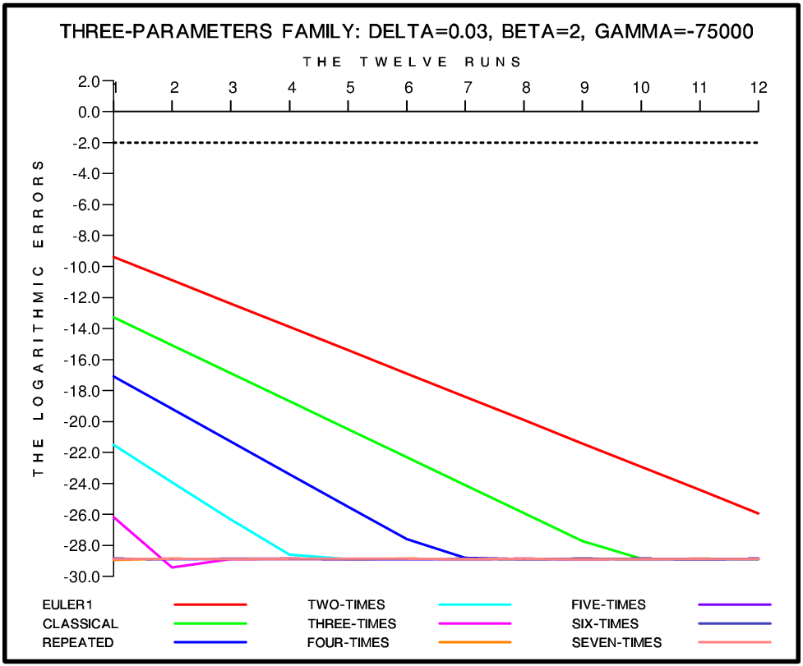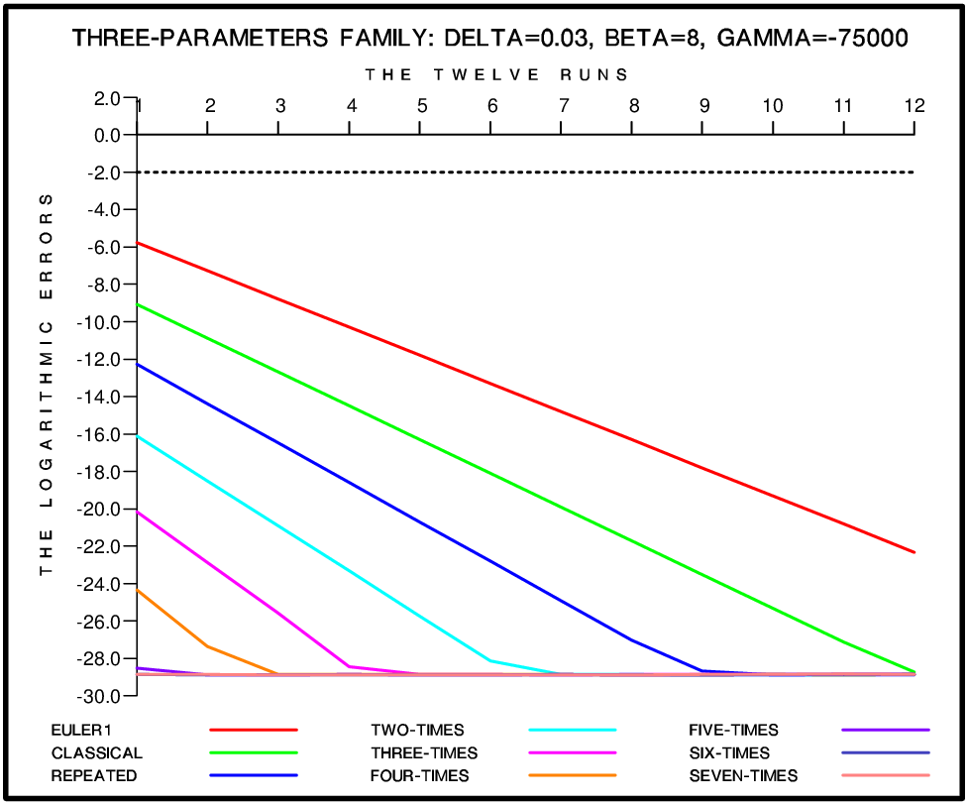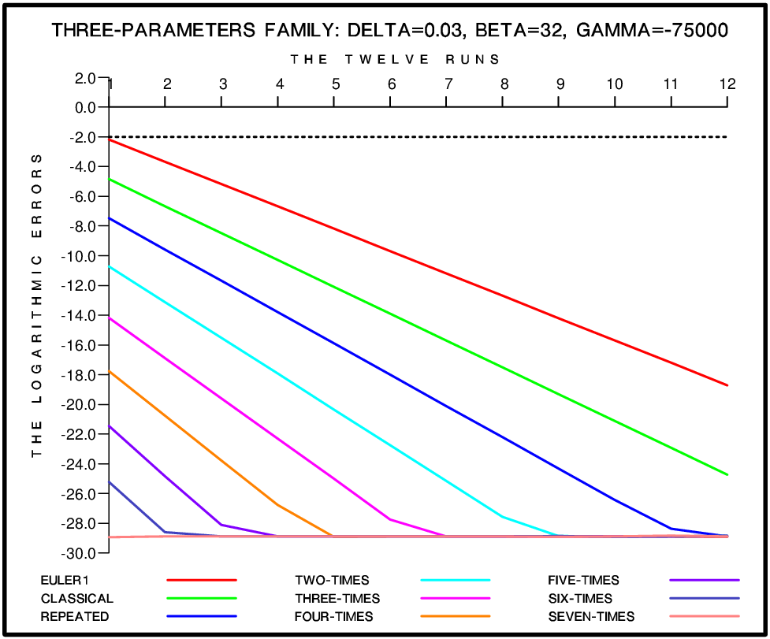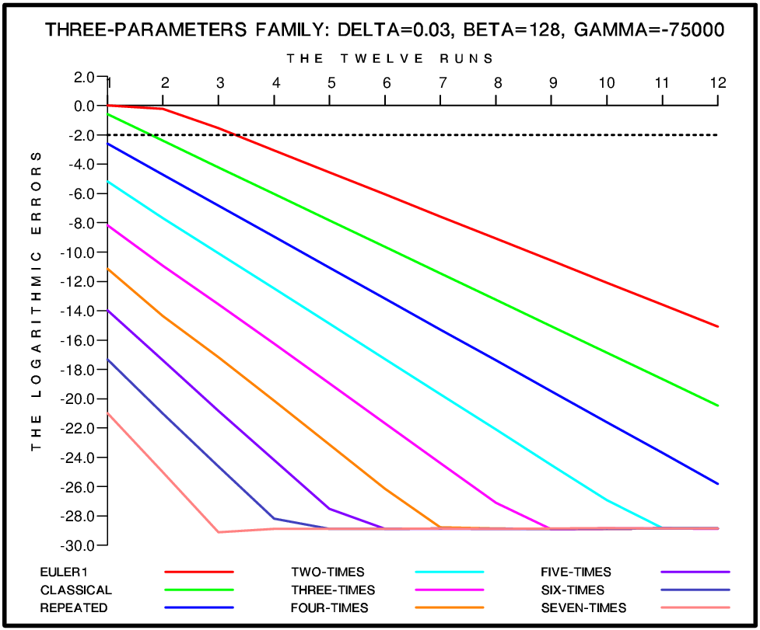
Figure 6
Logarithmic values of the errors in the solution vector when FIRK35 is used directly and with eight versions of the Richardson Extrapolation. Twelve different stepsizes are used and the errors are evaluated by applying (24) and (25). The names DELTA, BETA and GAMMA are used in the plots instead of $δ$, $ξ$ and $γ$.

[6] I. Faragó, Á. Havasi and Z. Zlatev: “Efficient implementation of stable Richardson Extrapolation algorithms”, Computers and Mathematics with Applications, Vol. 60 (2010), pp. 2309-2325 (https://doi.org/10.1016/j.camwa.2010.08.025).

[7] C. W. Gear: “Numerical Initial Value Problem for Ordinary Differential Equations”, Prentice-Hall, Englewood Cliffs, New Jersey, USA, 1971 (https://dl.acm.org/citation.cfm?id=540426).

[8] E. Hairer, S. P. Nørsett. and G. Wanner: “Solving Ordinary Differential Equations: I. Nonstiff Problems”, Springer, Berlin, 1987 (https://www.springer.com/gp/book/9783540566700).

[9] E. Hairer and G. Wanner: “Solving Ordinary Differential Equations: II Stiff and Differential-Algebraic Problems”, Springer, Berlin, 1991 (https://www.springer.com/gp/book/9783540604525).

Run | Steps | Stepsize | EULERB |  |  | DIRK23 |  | FIRK35
 |  |  | Error | Rate |  | Error | Rate | Error | Rate
1 | 640 | 0.02048 | 1.000E-00 | - | 1.000E-00 |  | - | 1.000E-00 | -
2 | 1280 | 0.01024 | 1.000E-00 | 1.00 | 1.000E-00 |  | 1.00 | 8.207E-01 | 1.22
3 | 2560 | 0.00512 | 1.000E-00 | 1.00 | 1.000E-00 |  | 1.00 | 5.312E-03 | 154.50
4 | 5120 | 0.00256 | 1.000E-00 | 1.00 | 1.842E-00 |  | 0.54 | 1.019E-05 | 521.30
5 | 10240 | 0.00128 | 4.087E-00 | 0.24 | 1.409E-01 |  | 13.07 | 1.687E-08 | 604.03
6 | 20480 | 0.00064 | 2.991E-00 | 1.36 | 2.582E-03 |  | 54.57 | 2.753E-11 | 612.79
7 | 40960 | 0.00032 | 6.885E-02 | 33.66 | 3.120E-05 |  | 121.79 | 6.649E-14 | 414.05
8 | 81920 | 0.00016 | 2.480E-03 | 27.76 | 2.760E-07 |  | 113.04 | 1.362E-16 | 488.18
9 | 163840 | 0.00008 | 8.200E-05 | 30.24 | 2.288E-09 |  | 120.63 | 2.678E-19 | 508.59
10 | 327680 | 0.00004 | 2.591E-06 | 31.65 | 1.787E-11 |  | 128.04 | 5.223E-22 | 512.73
11 | 655360 | 0.00002 | 8.033E-08 | 32.25 | 1.388E-13 |  | 128.74 | 1.018E-24 | 513.06
12 | 1310720 | 0.00001 | 2.493E-09 | 32.22 | 1.079E-15 |  | 128.64 | 1.992E-27 | 511.04
Table 4
Results obtained when the Three-times Repeated Richardson Extrapolation is used together with the three selected methods (EULERB, DIRK23 and FIRK35) in the solution of a test-example obtained by the three-parameter family with $δ=0$, $ξ=2048$ and $γ=75000$. The numbers of steps and the stepsizes are given in the second and the third columns of the table. In the remaining six columns the errors and the convergence rates are given (the perfect convergence rates are 32, 128 and 512 respectively). The three methods are not able to achieve the required accuracy (two correct significant digits) when the stepsize is large (see the grey areas in the table), but the theoretical convergence rates are achieved when the stepsize is sufficiently small.

[12] W. Hundsdorfer and J. F. Verwer: “Numerical Solution of Time-Dependent Advection–Diffusion–Reaction Equations”, Springer-Verlag, Berlin, 2003 (https://doi.org/10.1007/978-3-662-09017-6).

[13] W. Kutta: “Beitrag zur näherungsweisen Integration totaler Differentialgleichungen”, Zeitschrift für Mathematik und Physik, Vol. 46 (1901), pp. 435–453 (http://www-history.mcs.st-and.ac.uk/Biographies/Kutta.html).

[14] J. D. Lambert: “Numerical Methods for Ordinary Differential Equations: The Initial Values Problem”, Wiley, New York, 1991 (https://doi.org/10.1016/S0304-0208(08)71200-3).

[15] L. F. Richardson: “The Deferred Approach to the Limit, I—Single Lattice”, Philosophical Transactions of the Royal Society of London, Series A, Vol. 226 (1927), pp. 299–349 (https://doi.org/10.1098/rsta.1927.0008).

[16] C. Runge: “Über die numerische Auflösung von Differentialgleichungen”, Mathematische Annalen, Vol. 46 (1895), pp. 167–178 (https://doi.org/10.1007/BF01446807).

[17] L. F. Shampine: “Numerical Solution of Ordinary Differential Equations”, Chapman and Hall, New York – London, 1994 (https://doi.org/10.1201/9780203745328).

[18] L. F. Shampine and M. K. Gordon: “Computer Solution of Ordinary Differential Equations: The Initial Value Problem”, Freeman, San Francisco, California, 1975 (https://trove.nla.gov.au/version/12693184).

[19] Z. Zlatev: “Computer Treatment of Large Air Pollution Models”, Kluwer Academic Publishers, Dordrecht, Boston, London, 1995, now distributed by Springer-Verlag, Berlin (https://doi.org/10.1007/978-94-011-0311-4).

[20] Z. Zlatev and I. Dimov: “Computational and Numerical Challenges in Environmental Modelling”, Elsevier, Amsterdam, Boston, Heidelberg, London, New York, Oxford, Paris, San Diego, San Francisco, Singapore, Sidney, Tokyo, 2006 (https://www.elsevier.com/books/computational-and...in.../978-0-444-52209-2).

[21] Z. Zlatev, I. Dimov, I. Faragó, K. Georgiev and Á. Havasi: “Absolute Stability and Implementation of the Two-times Repeated Richardson Extrapolation together with Explicit Runge-Kutta Methods”, Lecture Notes in Computer Science. Vol. 11386 (2019), pp. 673-686 (https://doi.org/10.1007/978-3-030-11539-5_80).

[22] Z. Zlatev, I. Dimov, I. Faragó, K. Georgiev and Á. Havasi: “Explicit Runge-Kutta Methods Applied with Advanced Versions of the Richardson Extrapolation”, Computational Methods in Applied Mathematics, 2019 (https://doi.org/10.1515/cmam-2019-0016).

[23] Z. Zlatev, I. Dimov, I. Faragó and Á. Havasi: “Richardson Extrapolation: Practical Aspects and Applications”, De Gruyter, Berlin, 2017 (https://www.degruyter.com/view/product/484637).

[24] Z. Zlatev, I. Faragó and À. Havasi: “Stability of the Richardson Extrapolation together with the θ-method”, Journal of Computational and Applied Mathematics, Vol. 235 (2010), pp. 507-520 (https://doi.org/10.1016/j.cam.2010.05.052).

[25] Z. Zlatev, I. Faragó and Á. Havasi: “Richardson Extrapolation combined with the sequential splitting procedure and the θ-method”, Central European Journal of Mathematics, Vol. 10 (2012), pp. 159-172 (https://doi.org/10.2478/s11533-011-0099-7).

[26] Z. Zlatev, K. Georgiev and I. Dimov: “Studying absolute stability properties of the Richardson Extrapolation combined with Explicit Runge-Kutta Methods”, Computers and Mathematics with Applications, Vol. 67, (2014), pp. 2294-2307 (https://doi.org/10.1016/j.camwa.2014.02.025).

